The Aspiring Solopreneur

By Kris Kluver

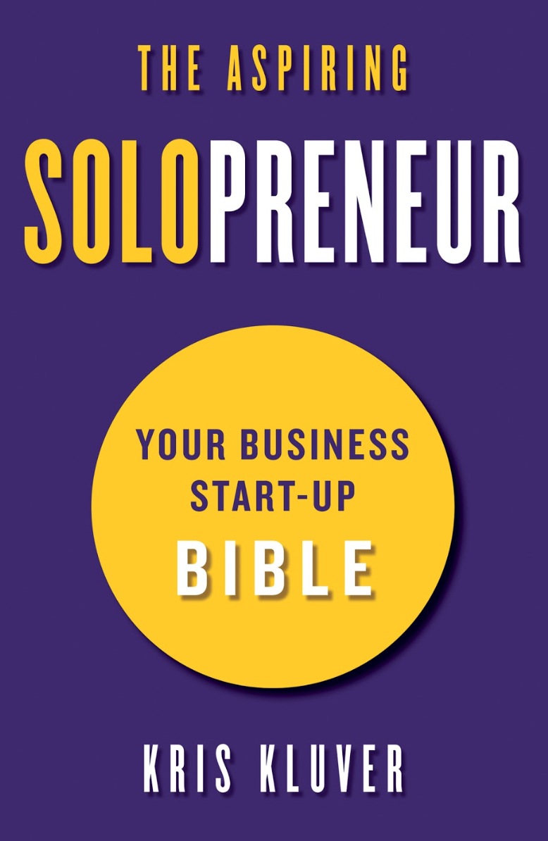

**1) Want to Clarify Your Unique Value Proposition? Think Like a Client (pgs 22 - 27).**

Pursue your enterprise in a way that you become not only the *best* at what you do, but the *only* person who does such-and-such thing. The author discusses how to think like a client to distinguish oneself in the market and solve a problem better than anyone else. The secret? Niching down on opportunities to address client's pain points using your own unique skill set.

**2) Building Your Success Guide: The Five Parts of a Killer Business Plan (pgs 193 - 211).**

The author breaks down the five essential planning documents (Advisory List, Roadmap, Financial Viability, Initial Timeline to Launch and Defined Accountabilities) needed to comprise a rock-solid business plan and gain a comprehensive understanding of the intricacies of the solopreneur's journey.

**3) Our Smart Devices Are Making us 3x *Less* Efficient. Here's The Solution (pgs 237 - 238).**

Multitasking is a myth, it doesn't work. It’s documented that in transitioning between hearing the ping of an email, reading the email, responding to the email, and getting back to focus on their original task people lose three times the time the actual task took. The author offers time blocking tips to help readers more efficiently accomplish goals.

**4) A Strategic Tool for a Better, Happier, More Energized *You* (pgs 249 - 252).**

As time progresses, you will need to start parsing your time more carefully, investing more time in what you love, are great at, and gives a high dollar value. The author introduces his Time Delegation and Allocation Matrix, a valuable tool for quantifying the value of one's time and understanding what needs to be outsourced.

The Aspiring Solopreneur / Release Date: September 3rd, 2019 / Cherokee Street Publishing